**Evil Santa: The Game**

**By Jesus Perez Arias, CS 2012-01**

Game Setup

Before you start, make sure you have the unzip the folder titled “jesusPerezFinal.zip” and have everything under one folder named “src” like the picture below on your desktop. Make sure to run “Main.java” as your Main class to ensure a smooth running of the game, there’s pictures below.

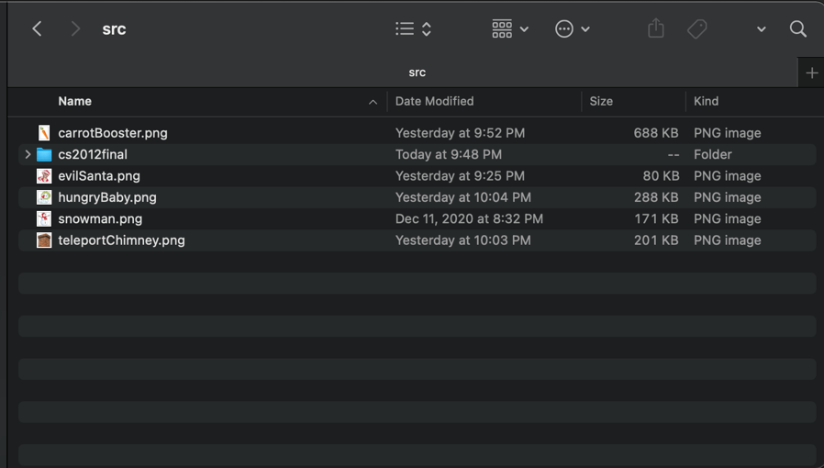

*On your Desktop*

*Inside Your IDE (integrated development environment)*

Starting the Game

When you run Main.java you will be presented with a window with a main menu with buttons saying grid sizes of “5 x 5”, etc. Choose one to start the game!

Progressing Through the Game

Your main goal is to traverse with your own “Chilly” the snowman by using the following arrow keys and to kill Imposter Santa who has come to ruin Christmas by stealing all of the good little children’s gifts. Your goal is to find Imposter Santa by finding him near the room where he is at and make sure to not enter his evil room of torture or he will kill you automatically (game over).



Chilly the Snowman

Press “W” to move up on the game grid.

Press “A” to move left on the game grid.

Press “S” to move down on the game grid.

Press “D” to move right on the game grid.

Below is what you will see once you start the game (you start default with debug mode off, the left image) and if you wish to “cheat” a little there is a button on the right of the window titled “debug mode” which shows where all the items, bosses, and even where Evil Santa is at.

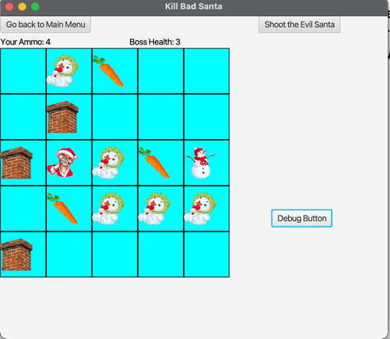



*Debug Button Off Debug Button On*

On top of the grid playing area, you will see a label titled “Your Ammo: 3” and your ammo will increase the more carrots you find on your journey to defeat Evil Santa.

Shooting Santa

You will be able shoot Evil Santa when you press the button titled “Shoot the Evil Santa” on the top right of the window and when this button is pressed, your ammo will decrease by one but if you manage to find the adjacent room to where Santa is then Evil Santa’s health will decrease by 1 until it reaches 0, then you win the game but…

Santa’s Mischievous Helpers

Beware as the little mischievous helpers of Evil Santa are also scattered across the game grid, they are here to interfere your mission to defeat Evil Santa. Be aware of the following mischievous helpers.

Naughty Snow Boy

This little critter will deplete your ammo by 1 carrot, 1 piece of ammo, they will not kill you but will deplete your ammo by 1. If your ammo reaches to 0 then there is no point on you journey and the game will end.

Teleport Chimney

This little chimney may seem all innocent at first glance but stay on top of your toes, this chimney will teleport you to a random position on the grid hindering your journey with human’s best resource, time.



Carrot Ammo Charger

Not everything is all sour, there are leftover carrots from the children making snowmen last year. Pick these up and watch your ammo charge up by 1 carrot (your ammo will increase by 1).

If that isn’t a win then oops.

Starting with a Fresh Slate

At any moment you wish to stop the game and start over with a new grid and a new board of enemies, there is a “Go Back to Main Menu” at the top left of the window to start a fresh game board.

That’s it, go help Chilly the Snowman defeat evil Santa and I wish you happy holidays!

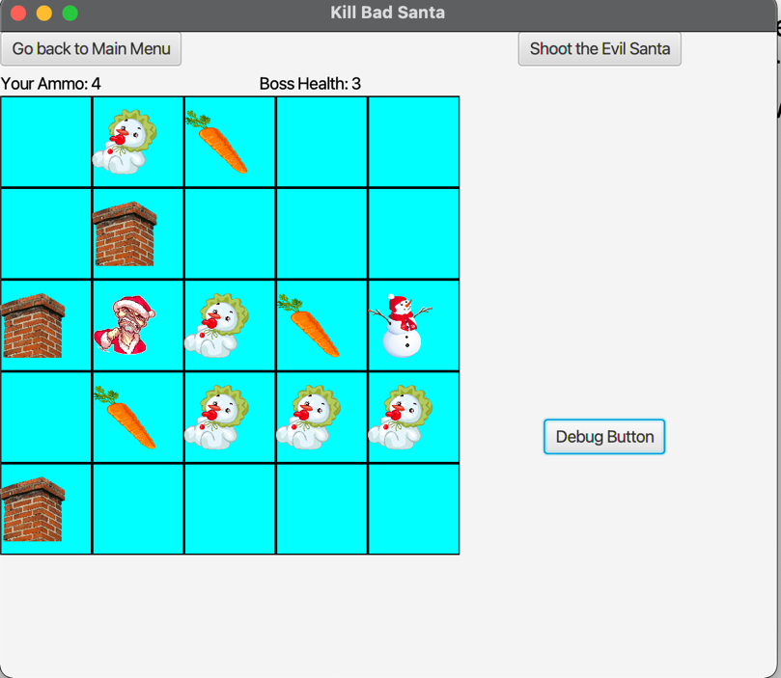



*Start Over Anytime*

Link Sources:

All images were found under <https://www.cleanpng.com/>, a website where all PNG’s are free to use for personal projects.